B2B VETO 2012 – Visual Bonus A

A[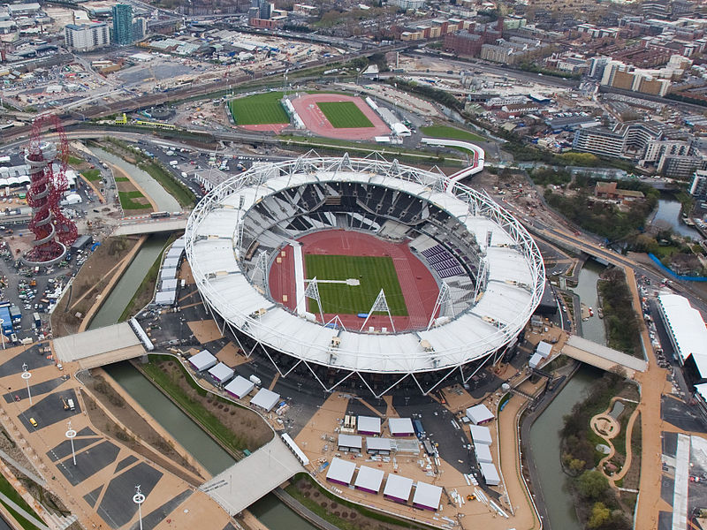](http://upload.wikimedia.org/wikipedia/commons/7/7d/Olympic_Stadium_%28London%29%2C_16_April_2012.jpg)

B[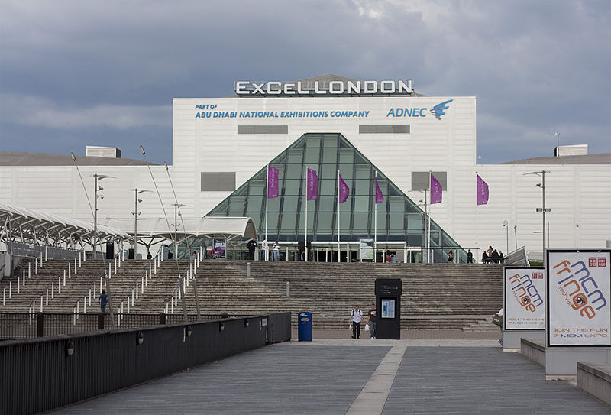](http://upload.wikimedia.org/wikipedia/commons/4/4e/Excel_London_Summer_2011.jpg)

C[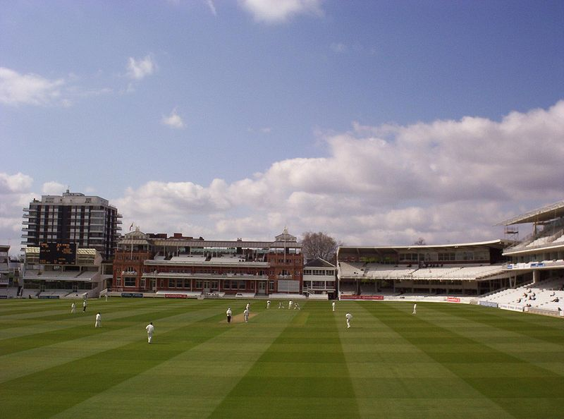](http://upload.wikimedia.org/wikipedia/commons/8/81/Lord%27s_Cricket_Ground_Heath_Streak.jpg)