VETO 2014
Packet by “Something About Fur Trapping” (Mike Bentley, Brittany Bentley, Andrew Hunter, Michael Land)

Tossups

1. The title object describes how it puts out fires in this man’s story "A Rill from the Town Pump", while "the Slide" kills the residents of Notch in his "The Ambitious Guest". A man jumps into the fire of a lime-burner after discovering the Unpardonable Sin in his "Ethan Brand". Elizabeth breaks off her engagement with Reverend Hooper after he starts wearing the title object in another of his works. For 10 points, name this author of Twice-Told Tales like "The Minister's Black Veil" and "Dr. Heidegger's Experiment".
ANSWER: Nathaniel Hawthorne

2. In surf clam eggs, these things contain RNA sequences. Both structural and numeric aberrations of these can be found in tumor cells. Like DNA, replication of this organelle is semi-conservative, and cdk2 acts as a regulator. Cells which lack this organelle cannot have astral microtubules. For 10 points, name this organelle, composed of two cylindrical structures of tubulin, which regulates much of the cell-cycle by serving as the microtubule organizing center of the animal cell.
ANSWER: centrosome [anti-prompt on “centriole” before “two cylindrical structures” is read]

3. One monarch from this family personally designed the Tuileries Palace. Another attempted to dismiss her son's chief minister on the Day of the Dupes. A queen from this family responded to an assassination attempt on Admiral Gaspard de Coligny by permitting the murder of hundreds of French Huguenots in the Saint Bartholomew's Day Massacre. Henry II’s wife Catherine came from this dynasty. For 10 points, name this dynasty which ruled Florence under Lorenzo the Magnificent.
ANSWER: Medici

4. This author of the memoir Do Your Love Football?! established the Fired Football Coaches Association. He was an offensive-coordinator under Ray Rhodes in Philadelphia. His younger brother Jay went on to an Arena Football career after playing QB for Louisville. In this coach’s only Super Bowl win, Dexter Jackson was named MVP. In 2002, he replaced Tony Dungy. He is the color commentator to Mike Tirico on Monday Night Football. For 10 points, name this coach who won a Super Bowl with Tampa Bay.
ANSWER: Jon (David) Gruden

5. This nation’s capital is home to the Ristik Palace and the Kale [Kah-lay] Fortress. A noted Stone Bridge in this country’s capital spans its longest river, the Vardar. It’s not Albania, but Lake Ohrid is located in its Galicica [Gah-lee-cheet-sa] National Park. The second largest city in this landlocked country is Bitola, which served as the last capital of the Ottoman province of Rumelia, and was founded as Heraclea Lyncestis. For 10 points, name this Balkan nation with capital at Skopje, whose name is disputed by Greece.
ANSWER: Former Yugoslav Republic of Macedonia [accept FYROM]

6. Only one such function into any Hausdorff space exists with given values on a dense subset of this domain. For linear operators on normed spaces, this property is equivalent to boundedness. A homeomorphism is an invertible function f where both f and f-inverse have this property. In topology, the formal definition of this property is that the inverse image of open sets is open. For 10 points, name this property of functions where sufficiently small changes in input result in small changes in output.
ANSWER: continuity [or continuous functions]

7. Five years before this man took power, Charles Lennox Richardson was killed, sparking an international incident. This man abolished the han system and divided his realm into 72 prefectures. This second son of Komei moved to Akasaka Palace following the destruction by fire of another residence. This man took the Charter Oath in 1868 and put down the Satsuma Rebellion. For 10 points, name this Japanese Emperor, the namesake of a “restoration” that ended the Tokugawa Shogunate.
ANSWER: Meiji Emperor [or Emperor Meiji the Great or Mutsuhito]

8. Some of the most intensive explorations of this place were done by Harry B. Whittington. The Walcott Quarry is located near a massive wall in this place called the Cathedral Escarpment. It is to the north of Kootenay National Park. This UNESCO World Heritage Site was likely created by a mud slide from the Laurentian shelf. This place provided evidence of the unusual Wiwaxia and Hallucigenia species and others from the Middle Cambrian period. For 10 points, name this large fossil field in British Columbia.
ANSWER: Burgess Shale Formation

9. Ileana Ros-Lehtinen argued that Raul Castro scored a propaganda coup during this event. David Cameron, Helle Thorning-Schmidt and Barack Obama were criticized for taking a selfie during this event. An expensive charter flight to this event prompted a scandal which ended with Alison Redford's resignation as Premier of Alberta. Thamsanqa Jantjie pretended to interpret sign language during this event. For 10 points, name this 2013 event presided over by President Jacob Zuma which mourned the loss of a South African leader.
ANSWER: Nelson Mandela's Funeral [accept equivalents for funeral like memorial]

10. This artist collaborated with a group of nine year olds to produce a 150-foot mural titled The Imagination Isles. The title pioneer stands in front of a map in his German-influenced Portrait of John B. Turner. A child with an old man's head holds an axe in his Parson Weem's Fable and he also painted Herbert Hoover’s birthplace. The title figures may be cross-dressers and stand before an Emanuel Leutze painting in his Daughters of Revolution. For 10 points, name this Regionalist painter of American Gothic.
ANSWER: Grant Wood

11. A bank named for this family was established from profits from the founding of Montreal’s first gas-lighting operation. In 1810, one man with this surname was the main purchaser of the Accommodation, the first steamboat to be built entirely in North America. That same man with this last name financed Canada's first railroad. This family annually awards a $50,000 prize in the arts. Members of this family once owned Beaver Lumber and today control the Canadiens. For 10 points, name this family which founded Canada's oldest brewery.
ANSWER: Molson [or the Molsons]

12. The speaker describes his approach to writing a poem on an orange in contrast to Mike Goldberg in a Frank O'Hara poem titled, "Why I'm Not [one of these people]". One person in this profession recounts how after "that long festal year at Fontainebleau" he purchased a house for his wife Lucrezia with money given to him by Francis I and is described as being “faultless”. For 10 points, name this profession of the title character of Robert Browning's poems, "Andrea del Sarto" and “Fra Lippo Lippi”.
ANSWER: Painter [or Artist; accept “Why I’m Not An Artist”]

13. Herodotus described the self-growing roses in a garden planted by this man. Alexander the Great once loosened the cord of a wagon made famous by this man. One of his secrets was spilled by an over-eager barber who whispered it into a hole in the ground. This man was saved from starving to death after bathing in the Pactolus River, releasing him from a dubious gift granted to him by Silenus. For 10 points, name this ass-eared Phrygian king who turned everything he touched into gold.
ANSWER: King Midas

14. One game in this series contains an advertisement for a fourteen hour rendition of Hamlet. One character, known having reach but lacking flexibility, briefly goes by "Archangel". L2 implants cause migraines in one man in this series, who later recovers from other injuries in a Citadel hospital. In its first installment, the protagonists are called "rudimentary creatures of blood and flesh." Featuring species like hanar, elcor, volus and asari, for 10 points, name this franchise of video games where the Reapers are fought by Commander Shepard.
ANSWER: Mass Effect

15. One version of this piece was originally written for a fireman’s choir and was famously recorded by Chanticleer; that version was composed by Franz Biebl. Another version of this piece repurposed the melody from Ellens dritter Gesang from The Lady of the Lake. Rachmaninov's "Bogoroditsye Djevo" is a version of this piece. Protestants sometimes replace the lyrics in this piece using words like "Redemptor". For 10 points, name this often-set Latin text, a prayer whose subject is "blessed among women."
ANSWER: Ave Maria

16. A novel with these figures in the title centers on a Rabelais manuscript gifted to the College of St. John of the Holy Ghost and sees Maria embrace her Roma roots and abandon classics professor Simon Darcourt. These figures appear in the title of a novel where books mysteriously disappear from a library look after by Julien Sariette and owned by the d'Esparvieu family. Robertson Davies described "rebel" ones, and Anatole France wrote of the revolt of these figures. For 10 points, name these figures that include Raphael and Michael from Paradise Lost.
ANSWER: Angels [accept Rebel Angels or Revolt of the Angels or Archangels]

17. One application of this technique employs similarity matrices and is named for Smith and Waterman; that example is a variation of another named for Needleman and Wunsch and is used in bioinformatics. This method can also be used to find the Levenshtein distance or solve the Longest Common Subsequence problem, and it often includes a recurrence relation. For 10 points identify this programming method, exemplified by Floyd-Warshall, which breaks complex problems into simpler sub-problems.
ANSWER: dynamic programming [accept word forms, accept sequence alignment or sequencing before bioinformatics]

18. Note: First or last name acceptable. This person first gained fame in a documentary by Adam Ellick. Phone conversations with this person were posted by a BBC reporter onto a blog under the pseudonym Gul Makai. Christina Lamb co-authored a memoir with this person and wrote a Sunday Times article on her year with this person. This 2013 winner of the Sakharov Prize was sent to a Birmingham hospital after being shot three times on a bus in Swat. For 10 points, name this Pakistani youth and anti-Taliban activist.
ANSWER: Malala Yousafzai [accept either underlined answer]

19. Maxim Gorky declared that this dance, popular at dances hosted by the American Relief Administration, led to homosexuality, and many former Russian aristocrats were sent to the gulag for doing this dance in a namesake affair of the 1920s. Supposedly named for a vaudeville actor, slow and fast steps are used for half and quarter notes respectively in its ragtime-influenced 4/4 music. For 10 points, identify this dance which also names the sixth letter in the NATO phonetic alphabetic and a Bill Amend comic strip.
ANSWER: Foxtrot

20. James Horton and Joseph Matthews received the Medal of Honor for helping to fix this thing during the Paris Exposition of 1878. Paul Revere is credited with providing copper sheathing and bolts to this thing. James Richard Dacres tried to destroy it, although Isaac Hull helped it escape the British. It earned its popular nickname after several shots from the Guerriere supposedly bounced off its hull. For 10 points, name this flagship of Edward Pebble in the war against Tripoli, known as “Old Ironsides”.
ANSWER: USS Constitution [prompt on "Old Ironsides" before the end]

21. A recently translated novel by this author contains a dwarf and his lame brother who were both beaten as children by Fatma. The protagonist of another of his novels finances the film Broken Lives and steals objects from his cousin Fusun to form the title collection. The poet protagonist returns from Germany to the town of Kars to re-unite with Ipek and writes a poem on the title weather phenomenon in a work by this author of The Museum of Innocence. For 10 points, name this Nobel-winning Turkish author of Snow.
ANSWER: (Ferit) Orhan Pamuk

22. Ewald summation or the fast multipole method can be used to efficiently approximate the forces involved in this problem, while a Barnes-Hut simulation can be used if collisions are irrelevant. It's not Fermat's Last Theorem, but the general case of this problem is easily solved exactly when a particular parameter is two; when that parameter is three, Sundman created a solution in powers of the cube root of t. If one mass is neglible, a family of constant-pattern solutions are described by Langrange points. For 10 points, give this system of coupled differential equations describing the motion of a set of objects interacting under gravitational or Coulomb forces.
ANSWER: n-body problem [accept molecular dynamics and prompt on 3-body until "is three"]

23. This man wrote a response to John Locke’s An Essay Concerning Human Understanding, in which Locke was portrayed as Philalethes and this man was portrayed as Theophilus. Among this man’s better-known contributions to Philosophy are his Principle of Sufficient Reason and his theory of Pre-Established Harmony. This man’s most famous work on metaphysics is titled Monadologie. For ten points, name this German philosopher whose Law of Continuity and Transcendental Law of Homogeneity aided in the development of non-standard analysis.
ANSWER: Gottfried Wilhelm von Leibniz

24. Ideal species of molecules of this geometry belong to point group D3H. A cation with formula CH6N3+ has this model of molecular geometry, as does phosgene. In organic chemistry, carbon centers with this property are described as having SP2 Hybridization. A compound produced by the catalytic oxidation of methanol is an example of a non-ideal form of this geometry. Amines which undergo nitrogen inversion briefly have this geometry. For 10 points, name this model of molecular geometry which is exemplified by boron trifluoride and sulfur trioxide.
ANSWER: trigonal planar

25. Act II of this play ends with the daughter of a rich landowner yelling “It is a dream!” while lost in thought. Vera Komissarzhevskaya was booed at this play’s premier. Minor characters in this play include a doctor named Eugene Dorn and a schoolmaster named Simon Medviedenko. A play-within-a-play in this work contains the memorable line “Satan, my mighty foe, advances; I see his dread and lurid eyes.” For ten points, name this play famously directed by Constantin Stanislavsky, which tells the various conflicts between Nina, Irina, Konstantin, and Trigorin by Anton Chekov.
ANSWER: The Seagull [accept Chayka]

26. Some developmental economists criticize this idea as leading poor countries to avoid modernization. Modern Heckscher-Ohlin models suggest exploiting this concept through specialization in goods with abundant local production factors; without this development, the original theory could not explain trade between technological equals. The concept was alluded to in The Wealth of Nations, but a famous example involving wine and cloth is usually cited as its source. Originally formulated in On the Principles of Political Economy and Taxation by Ricardo, for 10 points, name this economic concept where relative efficiency differences lead to gains from trade.
ANSWER: comparative advantage

27. One character in this film admits to watching another sleep, who in turn pays off a bet to the first man's boss. One man steals iridium while his temporary ally is told "there are always men like you" after ordering Germans to kneel. A man wearing armor tells a man holding a weapon "doth mother know you weareth her drapes?" Another character admits to having "red in my ledger" before she is called a "mewling quim" by an adopted Asgardian. A demigod, a super soldier, a man with breathtaking anger issues all help repel Chitauri led by Loki while allied with Black Widow, Iron Man and Hawkeye, in, for 10 points, this Joss Whedon film about a Marvel superhero team.
ANSWER: The Avengers [or Marvel Avengers Assemble]

Bonuses

1. This play contains a notable monologue by the character Valentine, and the character of Thomasina Coverly is based on Ada Lovelace. For 10 points each:
[10] Name this play which tells parallel stories of scholars in an English country house, one set in the early 19th century and one set in the present day.
ANSWER: Arcadia
[10] Arcadia was written by the same playwright as this 1966 absurdist play which opens with the two title characters flipping coins. Characters in this play include Fortinbras.
ANSWER: Rosencrantz and Guildenstern are Dead
[10] Both Arcadia and Rosencrantz and Guildenstern are Dead, as well as The Real Inspector Hound were written by this Czech-British playwright.
ANSWER: Tom Stoppard [or Thomas Straussler]

2. This agreement was prompted by the work of chemists Frank Sherwood Rowland and Mario Molina 15 years earlier. For 10 points each:
[10] Identify this late '80s agreement which phased out the use of CFCs.
ANSWER: The Montreal Protocol on Substances that Deplete the Ozone Layer
[10] The Montreal Protocol helped save this region of the atmosphere. The discovery of a hole in this region helped convince several nations to sign the agreement.
ANSWER: ozone layer
[10] Canada has passed two bills with the name "Clean Air Act". Another country's Clean Air Act was passed follow the 1952 Great Smog in this city where visibility was reduced to as little as three feet.
ANSWER: London

3. This ethnic group was likely offended when Brian Mulroney offered condolences to Rajiv Gandhi, given that many of them perished in the bombing of a flight taking off from Montreal in 1985. For 10 points each:
[10] Identify this ethnic group that makes up about 3% of Canada's population. Former Canucks Centre Manny Malhotra is of this ethnicity.
ANSWER: East-Indo-Canadian [or Indian-Canadians; don't accept thing likes "Native Canadians" or "First Nations People"]
[10] After being rejected from entering this Canadian city in 1914 in the Komagata Maru incident, a group of Indians staged a protest against the British government. In the 1930s, Mayor Gerry McGeer read the Riot Act to a group of unemployed people in Victory Square Park in this city.
ANSWER: Vancouver
[10] A minor-wave of people of Indian origin entering Canada began after countries in this general region of Africa introduced policies of Africanization. A refugee crisis named for this region of Africa took place following the Rwandan genocide.
ANSWER: African Great Lakes

4. Identify the following about the business ventures of Michael Jackson, for 10 points each.
[10] Jackson famously bought ATV Music Publishing in the mid-1980s, which owned the catalog of this pretty popular band. The move gave Jackson control of this band's songs like "We Can Work It Out" and "A Day in the Life".
ANSWER: The Beatles
[10] Jackson planned to spend $500 million to build the World of Childhood amusement park in this country. The song "To nie ja!" from this country got second in the 1994 Eurovision competition, and a director born in this country made the films Carnage and The Ghost Writer.
ANSWER: Poland
[10] For his 1996-7 world tour, Jackson sold a drink and a magazine of this name. Michel St-Pere founded a Canadian prog-rock band with this name, and it's the name of the town the where Skank Marden plays Saturday hockey games in a 1999 film.
ANSWER: Mystery Drink [or Mystery Magazine; accept Mystery, Alaska]

5. Identify these recent happenings related to a group which does not contain Dimetrodon, for 10 points each.
[10] A volunteer at a Colorado dig site in June 2014 found a 6 foot 7 inch femur, the largest found so far by almost a foot, of this large sauropod, which lived alongside its relatives, Brachiosaurus and Diplodicus. This animal was formerly known by another name relating to thunder.
ANSWER: Apatosaurus [grudgingly accept Brontosaurus but let them know you are judging them]
[10] The Apatosaurus thrived during this period, which came after the Triassic.
ANSWER: Jurassic period
[10] A new species belonging to this group of horned dinosaurs was recently named based on fossils from Montana and Alberta. It was also recently determined that the most famous member of this group was actually a juvenile Torosaurus.
ANSWER: Ceratopsian [or Ceratopsia or Ceratopia or Ceratopsids or Ceratopsidae; accept Triceratops]

6. Ila Chattopadhay and Professor Mishra both teach English in this novel. For 10 points each:
[10] Identify this massive novel where Mrs. Rupa Mehra attempts to find the title husband for Arun, her daughter.
ANSWER: A Suitable Boy
[10] A Suitable Boy was written by Vikram Seth, a novelist from this nation also the birthplace of Anita and Kiran Desai.
ANSWER: India
[10] Seth’s third novel centers on Michael and Julia, who are both in this profession. It’s not construction, but Richard Katz is in this profession in Jonathan Franzen’s novel Freedom.
ANSWER: professional musicians [accept more specific answers like violinists or pianists or indie rock stars]

7. This result can be stated but not proved in non-relativistic quantum theories. For 10 points each:
[10] Name this result that demonstrates a relationship between values of a particular parameter for a particle and the eigenvalue of an operator that switches the position of two such particles.
ANSWER: spin-statistics theorem
[10] The spin-statistics theorem tells us that this class of particles with half-integer spin are antisymmetric under exchange. All quarks and leptons, as well as particles like protons and neutrons containing three quarks, are these.
ANSWER: fermions
[10] Fermions, as a consequence of antisymmetry, obey this rule, responsible for electron shells and degeneracy pressure.
ANSWER: Pauli exclusion principle

8. Visual Bonus. Given three paintings of religious scenes, identify the scene and the artist, for five points each. You have 20 seconds.
A. The Annunciation by Fra Angelico [or Guido di Pietro or Fra Giovanni Angelico]
B. The Assumption of the Virgin [or The Assumption of Mary] by El Greco [or Doménikos Theotokópoulos]
C. The Deposition of Christ [or the Descent from the Cross] by Rogier van der Weyden [or Roger de la Pasture; accept any underlined answer for him]

9. One character in this profession declares "I have never been so tempted to write romances, as when with Fat Maksim" and is warned to avoid Copenhagen on her trip to Stockholm. For 10 points each:
[10] Identify this profession of Sophia Kovalevsky, the title character of the story “Too Much Happiness”.
ANSWER: mathematician [prompt on “professor”]
[10] Too Much Happiness was written by this Nobel-winning Canadian master of the short story.
ANSWER: Alice Munro
[10] In the Too Much Happiness story “Wenlock Edge”, the protagonist is invited to perform this action naked. Hanna Schmitz is unable to perform this action in a 1995 novel by Bernhard Schlink made into a film starring Kate Winslet.
ANSWER: reading aloud

10. Until 2007, the Koryak Autonomous Okrug was located in the northern part of this region. For 10 points each:
[10] Name this region in the Far-East of Russia, located between the Pacific Ocean and the Sea of Okhotsk, which is home to many active volcanoes and the country’s largest submarine base.
ANSWER: Kamchatka Peninsula
[10] Another important Russian sea port is this city, the largest on Russia’s Pacific coast. This city is home to the Russian Pacific Fleet, and is located not far from the Chinese and North Korean borders.
ANSWER: Vladivostok
[10] About 400 miles to the north of Vladivostok is this relic of Stalin’s nationality policy. Despite this Oblast’s name, members of its namesake ethnicity make up only about one percent of the total population.
ANSWER: Jewish Autonomous Oblast [also accept J.A.O.]

11. Identify these Canadians who passed away in 2014, for 10 points each.
[10] This long-time editor of fiction at The University of Windsor Review first gained fame when his story "The Boat" was strangely included in the 1969 edition of Best American Short Stories. His short story collections include The Lost Salt Gift of Blood and As Birds Bring Forth the Sun and Other Stories.
ANSWER: Alistair MacLeod
[10] Dave Gregg, a guitarist who played on albums like Something Better Change for this influential hardcore punk band died of a heart attack in March. Hardcore '81 is another album by this Shithead Keithley-fronted band.
ANSWER: D. O. A.
[10] In February, Chris Pearson, who served as the first Premier of this province, died. It gained responsible government in 1979.
ANSWER: The Yukon Territory

12. Identify the following about American choral conductor Robert Shaw, for 10 points each.
[10] Shaw won a Grammy for his setting of this piece, which contains the famous “Hallelujah Chorus”.
ANSWER: Handel’s Messiah
[10] Shaw won another Grammy for a recording of J. S. Bach’s Mass in B-Minor, also a favorite of the Proms, a series of summer concerts put on by this organization from Royal Albert Hall.
ANSWER: The BBC [or British Broadcasting Company]
[10] Shaw also recorded this Samuel Barber cantata, divided into four movements each representing a single prayer. The first movement, named for a philosopher, is titled "O Though Who Art Unchangeable" and speaks of a God moved by the "need of a sparrow" in Gregorian-style chant.
ANSWER: Prayers of Kierkegaard

13. This trip was made on the steed Buraq and culminated with a salat said with Abraham, Moses and Jesus. For 10 points each:
[10] Identify this trip, which was followed by the Mi’raj or Muhammad’s ascent into heaven.
ANSWER: the Night Journey [or Isra]
[10] Muhammad’s Night Journey took him to this city, site of the Dome of the Rock.
ANSWER: Jerusalem
[10] According to one of these texts, Muhammad proved to a doubting kinsman that he had actually visited Jerusalem on his Night Journey by vividly describing the city. These texts are placed into categories like hasan.
ANSWER: hadiths

14. Its maker does not own or operate distilleries, and their source from the Stizel-Weller facility may soon run out. For 10 points each:
[10] Name this brand of liquor with a cult following, especially for its 23-year-old variety.
ANSWER: Pappy Van Winkle's Family Reserve
[10] Pappy is this type of whiskey, which by American standards must be at least 51% corn and aged in new, charred oak barrels. Contrary to popular belief, there is no requirement for it to be produced in a particular region of the country.
ANSWER: bourbon whiskey
[10] This other brand of bourbon, which uses James Carville as a spokesman for the "cocktail party", faced controversy for a 2013 plan to dilute new product from 45% to 42% alcohol due to dramatically increased demand. Suntory bought this brand in 2014.
ANSWER: Maker's Mark

15. This work divides dramatic tragedy into six elements, and gives matter, subjects, and method as the three genres of the title concept. For 10 points each:
[10] Name this work of Greek philosophy, considered the earliest extant piece to focus on dramatic and literary theory.
ANSWER: The Poetics
[10] Poetics was written by this Greek philosopher who studied at Plato’s Academy before founding the Lyceum.
ANSWER: Aristotle
[10] This second-most important element in tragedy can be translated as “strength of character” or “trustworthiness”.
ANSWER: ethos

16. An example of a substance which defies the more specific form of this law is glass, due to it having more than one minimum microscopically distinct energy state. For 10 points each:
[10] Name this law which states that the entropy of a system approaches a constant value as the temperature approaches absolute zero.
ANSWER: Third Law of Thermodynamics
[10] Quantum spin liquids still exhibit this property at absolute zero, thus they may have zero entropy at absolute zero. The Curie-Weiss law applies materials exhibiting this property.
ANSWER: paramagnetism [accept word forms]
[10] The third law of thermodynamics is derived from a more basic equation which equates the change in entropy to the natural log of the number of microstates consistent with macroscopic configuration multiplied by this value.
ANSWER: Boltzmann’s Constant

17. Identify the following about the life of the Greek explorer Pytheas, for 10 points each.
[10] Pytheas hailed from this modern day city. Volunteers from this city where Alexander I of Yugoslavia was assassinated famously sang “The War Song of the Rhine Army” in 1792.
ANSWER: Marseilles [or Massilia]
[10] Some scholars date Pytheas' voyages between 310 and 306 BCE, owing that the only time he could have reached the Pillars of Hercules was when this city state was distracted fighting with Syracuse. It was destroyed in the Third Punic War.
ANSWER: Carthage
[10] Pytheas supposedly circumnavigated this island. A Roman province on this island included settlements at Eburacum and Verulamium, the latter of which was a center for the Vatuvellauni before the Romans took over.
ANSWER: Great Britain [or Britannia; do not accept "England" or the "United Kingdom"]

18. The inhabitants of these islands speak with a dialect similar to that found in Normandy, although Basque was also spoken until the 1950s. For 10 points each:
[10] Name this small archipelago, located at the entrance to Fortune Bay, just off the coast of Newfoundland.
ANSWER: Saint Pierre and Miquelon [pronounced: Meek-lawn]
[10] Saint Pierre and Miquelon is all that is left of this former colonial empire that once stretched from Louisiana to Quebec.
ANSWER: New France [accept Nouvelle-France, prompt on “French Empire”]
[10] French colonists also established several forts and settlements in this modern-day US State, surviving examples of which include Cahokia and Peoria.
ANSWER: Illinois

19. One sub-domain of this goddess was Nastrond which was like a seashore, except filled with corpses. For 10 points each:
[10] Identify this goddess who ruled over a namesake underworld.
ANSWER: Hel
[10] Hel is the daughter of this Norse trickster god who likes to shape shift and engineered the death of Baldr.
ANSWER: Loki
[10] Murderers and other jerks had the pleasure of getting their blood sucked out of their bodies by this dragon who resided in Hel. This dragon also likes to nibble on the roots of Yggdrasill.
ANSWER: Nidhoggr

20. Most of this magazine's staff fled to The American in 1906, in part because of controversy around its founder's extramarital affair. For 10 points each:
[10] Identify this magazine which published muckraking articles by authors like Burton J. Hendrick and Lincoln Steffens.
ANSWER: McClure's Magazine
[10] Ida Tarbell wrote a history of this company for McClure's. This company was founded by John D. Rockefeller.
ANSWER: Standard Oil Co., Inc.
[10] Staff writer Lincoln Steffens is best known for this book, which began life as a column of the same name in McClure’s. Individual subjects in this work included "Tweed Days in St. Louis" and "Philadelphia: Corrupt and Contented".
ANSWER: The Shame of the Cities

21. They directly generate almost all electric power on earth. For 10 points each:
[10] Name this class of device that uses a flowing fluid to rotate a shaft for useful power. Wind ones are probably the most visible examples.
ANSWER: turbines
[10] This term refers to the potential energy in the form of pressure and kinetic energy in the form of velocity that a fluid turbine extracts.
ANSWER: head
[10] The Pelton wheel, a type of turbine, was an improvement on the existing water wheel because it made use of this physical phenomenon, which is symbolized J.
ANSWER: specific impulse

22. Identify the following about what might be the largest act of environment warfare in history, as described on the Vancouver-based podcast, Caustic Soda, for 10 points each.
[10] That 1938 event involved this body of water, the second-longest in Asia, which is the cause of the 2nd and 3rd deadliest flooding events in history.
ANSWER: Huang He [or Yellow River]
[10] The flood took place during this 1937-1945 conflict. This war was sparked by the Marco Polo Bridge Incident.
ANSWER: Second Sino-Japanese War
[10] To create the flooding, the Nationalist troops bombed Huayuankou dam in this central province, as the Imperial army had seized Kaifeng and threatened to take over its capital, Zhengzhou.
ANSWER: Henan Province

23. This man earns the enmity of his stepfather Ganelon, who is eventually killed after Ganelon’s champion Pinabel loses in a trial by ordeal. For 10 points each:
[10] Identify this paladin of Charlemagne and owner of the Oliphaunt who titles a medieval work of French literature.
ANSWER: Roland [or Hruodland or Orlando]
[10] This Italian author used the same Roland legend for his epic poem, Orlando Furioso.
ANSWER: Ludovico Ariosto
[10] Orlando is in love with this daughter of the King of Cathay, but she rejects Orlando in favor of the Saracen knight, Medoro.
ANSWER: Angelica

24. Like similar recent speakers at Harvard, Rutgers, and Berkeley, this woman cancelled her appearance as Smith College's commencement speaker after students protested her "strengthening of imperialist and patriarchal systems that oppress and abuse women." For 10 points each:
[10] Name this woman, successor of Dominique Strass-Kahn in her current post which, like her term as French Finance Minister, she was the first woman to hold.
ANSWER: Christine Lagarde
[10] Lagarde heads this organization which, when it isn't strengthening patriarchy, makes loans to economies in crisis, which often come with controversial requirements for policy reform. It was founded at the Bretton Woods Conference.
ANSWER: IMF [or International Monetary Fund]
[10] The IMF is a big fan of austerity policies, as are proponents of austerity’s alleged success in this country. Valdis Zatlers was succeeded by Andris Bērziņš as President of this country in 2011.
ANSWER: Latvia

25. Hebert Bayer, a member of this group, created a namesake Architype which attempted to combine upper and lower case into one sans-serif typeface. For 10 points each:
[10] Identify this art institution whose instructors included Lyonel Feiniger and Walter Gropius.
ANSWER: The Bauhaus
[10] The Bauhaus was located in this country. Artists from this country like Max Beckmann were attacked for their allegedly Jewish-style art in the Degenerate Art exhibit.
ANSWER: Germany
[10] Paul Klee taught both painting and this other medium at the Bauhaus. Marc Chagall created works in this medium in Jerusalem and for the UN.
ANSWER: stained glass [prompt on just "glass"]

26. One of the plaintiffs in this case may have been motivated by trying to prevent the rise of the DiscoVision system being developed by its parent company, MCA. For 10 points each:
[10] Identify this 1984 Supreme Court case.
ANSWER: Sony Corp. of America v. Universal City Studios, Inc. [or the Betamax case; accept any underlined answer in any order]
[10] The Betamax case ruled that making copies of TV shows fell under this two-word safe harbor from copyright laws.
ANSWER: fair-use doctrine
[10] In this 2004 case, Streamcast and the namesake company were found liable to be sued for operating peer-to-peer file sharing services. Napster strangely filed a brief on behalf of the plaintiffs in this case.
ANSWER: MGM Studios, Inc. v Grokster, Ltd. [accept either underlined answer in either order]

27. Compound versions of these things cannot achieve resolution better than one degree. For ten points each:
[10] Name these organs, non-compound versions of which include the pit and reflector types.
ANSWER: eyes
[10] Humans, along with most other vertebrates, have a highly curved one of these, which along with the anterior chamber and lens refracts light similarly to water.
ANSWER: cornea
[10] Compound eyes, by contrast, feature many lenses arranged over a convex surface, and are found on most animals in this phylum, which includes insects and arachnids.
ANSWER: arthropoda [or arthropods]

28. Answer some questions about psychotherapy for 10 points each:
[10] This approach to therapy, one of the best supported in controlled trials, focus on challenging maladaptive thinking. Exploring the beliefs that direct those thoughts, patients can modify their patterns.
ANSWER: Cognitive behavioral therapy [or CBT]
[10] One derivative of CBT is dialectical behavior therapy, designed to treat this condition, characterized by impulsivity, instable affect, intense fear of abandonment and dissociation.
ANSWER: Borderline personality disorder [or BPD]
[10] While CBT and DBT are fairly well supported by clinical evidence, some psychologists claims that nearly all therapy methodologies are equally effective, since they all share common factors (notably, attention from a respectful, warm therapist.) It is named after a character in Alice in Wonderland.
ANSWER: Dodo bird verdict [or conjecture]

29. This policy was ended by the first of the Five Year Plans. For 10 points each:
[10] Identify this reversal of the policy of War Communism, which returned industries like retail shops and some forms of agriculture to private ownership.
ANSWER: New Economic Policy [or NEP or state capitalism]
[10] The New Economic Policy was promulgated by this Bolshevik leader who was once shipped back to Russia in a sealed train car to foment the Russian Revolution.
ANSWER: Vladimir Ilich Lenin [or Vladimir Ilich Ulyanov]
[10] Meanwhile, in Communist China, economic policies were liberalized under this influential member of the Standing Committee of the Political Bureau who helped oust Zhao Ziyang during the Tiananmen Square demonstrations.
ANSWER: Deng Xiaoping [or Teng Hsiao-p’ing]

Visual Bonus

A.
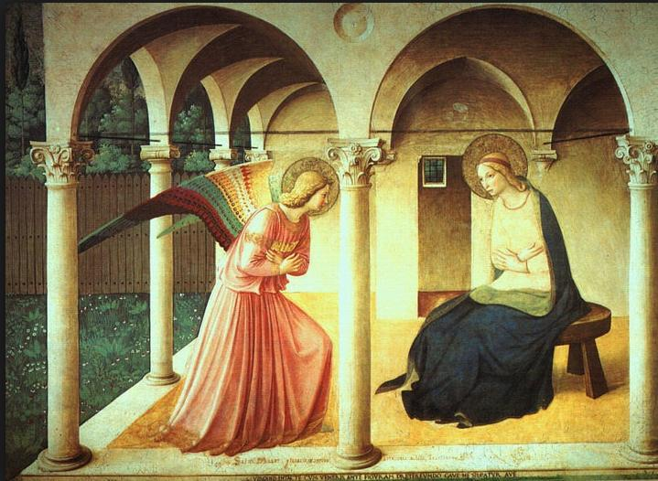

B.

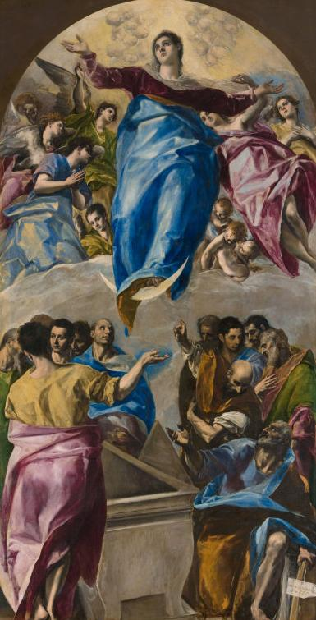

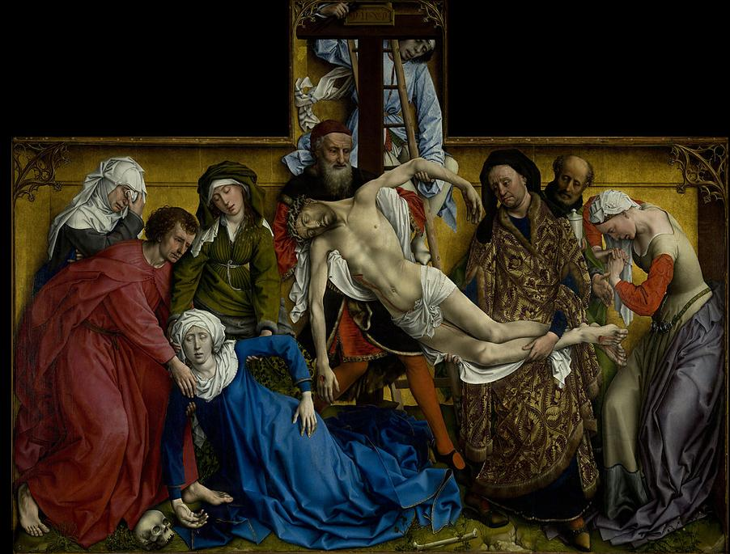

C.

